**Michigan EAB project – chapter draft**

Aaron Tayal

June 23, 2025

**Introduction**

Forests are increasingly impacted by anthropogenic stressors, including the establishment and spread of nonnative species (Lovett et al. 2006). Nonnative tree-feeding insects have been especially significant, causing economic and ecological impacts (Gandhi and Herms 2010, Van Driesche and Reardon 2016). Nonnative tree-pests can undergo exponential population growth because top-down and bottom-up processes are reduced in the invaded range. Nonnative insects introduced to a new region can escape their specialist natural enemies which might otherwise control their populations (Roy et al. 2011, Duan et al. 2023). Furthermore, native tree species do not share a coevolutionary history with nonnative insects and may lack the necessary physical or chemical defenses (Villari et al. 2016, Mech et al. 2019). Release from these top-down and bottom-up controls can lead to rapid and widespread mortality of host trees. Tree mortality causes direct and indirect ecological consequences which have short- and long-term impacts on forest structure and function. In the short term, tree mortality forms canopy gaps that increase light availability and temperature and alter soil moisture on the forest floor (Perry and Herms 2019). Depending on the size, surrounding canopy and understory trees or advanced regeneration will respond to the available resources and grow to fill the gaps. If the host tree species has surviving seedlings, saplings, or root sprouts, this regeneration may compete to reclaim the space. However, regeneration of a host tree species can be hindered by the continual presence of the nonnative insect. Eventually, host tree species may be functionally eliminated from forests, or they may persist (McCormick and Platt 1980). If they do persist, they may do so in a different size range, or only within certain forest types (Barnes 1976).

Emerald ash borer (EAB, *Agrilus planipennis* Fairmaire) is an introduced woodboring beetle (Coleoptera: Buprestidae) that has had substantial direct and indirect ecological impacts in forests (Klooster et al. 2018). First identified near Detroit, Michigan in 2002, EAB has since spread throughout the eastern United States and Canada. Extensive mortality of North American ash (*Fraxinus* spp.) has occurred in regions where EAB has become established, including widely distributed white ash (*Fraxinus americana* L.), green ash (*Fraxinus pennsylvanica* Marsh), and black ash (*Fraxinus nigra* Marsh) (Burns and Honkala 1990). For example, mixed deciduous forests near the epicenter of the EAB invasion experienced more than 99% mortality of canopy ash by 2009 (Klooster et al. 2014). Concurrent with the death of mature ash, viable seed production declined precipitously, which threatens to eliminate the genus *Fraxinus* from forests (Klooster et al. 2014). To control EAB populations, several biological control agents native to east Asia have been widely released in eastern North America. Three parasitoid wasp species have established and are impacting EAB populations (Duan et al. 2015, 2023, Aker et al. 2022, Quinn et al. 2023).

Although the majority of mature ash have died, ash seedlings and saplings that were too small to be colonized by EAB during the initial wave of mortality are abundant in many forest understories (Aubin et al. 2015, Ward et al. 2021). If this regeneration grows large enough to reproduce and generate viable seeds, then ash could remain a long-term component of eastern North American forests. However, EAB populations in post-outbreak forests remain at low densities. As ash saplings grow to larger sizes, they become susceptible, increasing the likelihood that persisting populations of EAB will kill them (Duan et al. 2017). Recent evidence suggests that the introduced parasitoids could provide enough EAB-population control to protect regenerating ash in post-outbreak forests (Duan et al. 2015, McCullough 2019). *Tetrastichus planipennisi* Yang (Hymenoptera: Eulophidae) parasitizes EAB larvae through the thinner bark of young ash trees (<12 cm in diameter) (Abell et al. 2012, Duan et al. 2023), while the longer ovipositor of *Spathius galinae* Belokobylskij (Hymenoptera: Braconidae) may allow it to parasitize EAB larvae within ash trees up to about 39 cm in diameter (Murphy et al. 2017). The long-term persistence of ash populations in natural forests of North America will depend on the dynamic interactions among the cohort of immature ash in the forest understory, competing plants, low-density EAB populations, and introduced parasitoids.

Although EAB attacks ash trees in a variety of habitats (Smith et al. 2015), the long-term persistence of ash may only occur in certain forest types. Ash trees occupy a variety of forests, including abandoned agricultural fields (Morris et al. 2023), mixed hardwood forests (Wagner and Todd 2015), riparian areas along streams (Engelken et al. 2020), river floodplains, and depressional areas such as near lakes (Siegert et al. 2021, Abella et al. 2024). Forests can be classified using a variety of abiotic characteristics, but hydrology is one of the most important because of its effect on tree species composition. Hydrology influences tree survival and growth (Megonigal et al. 1997, Niinemets and Valladares 2006), and different ash species have unique hydrologic requirements. Forest stands may be classified as xeric upland, mesic riparian, or hydric swamp, with hydric swamp forests experiencing flooding above the soil surface for at least part of the year. Ash trees play an outsized role in the function of hydric forests. Black ash is often a dominant species in hydric forests, due to its ability to tolerate seasonal flooding and maintain high levels of transpiration, which draws down the water table (Telander et al. 2015, Kolka et al. 2018). The long-term impacts of EAB may be distinct in hydric settings, due to the relative importance of ash in the canopy, the stress due to flooding, and the prevalence of sedges and flood-adapted shrubs in the understory (Smith 2006, Klooster 2012, Palik et al. 2012, Engelken et al. 2020). Understanding whether ash regeneration is occurring among different forest types, and whether ash populations are recovering in hydric forests will inform conservation and restoration efforts in post-outbreak forests.

Given the uncertain future of ash in eastern North American forests, it is important to understand the potential for ash survival and regeneration in invaded forests with low-density EAB populations and a history of biological control releases. We resurveyed long-term forest research sites established during the early stages of ash mortality near the epicenter of invasion to investigate the occurrence and health of ash populations more than two decades after the detection of EAB. Our first objective was to quantify the abundance and health of ash regeneration in hydric, mesic, and xeric forests. Because few reproductively mature ash remain alive in post-outbreak mixed forests (Ward et al. 2021), and the ash seed bank depleted quickly (Klooster et al. 2014), we predicted that newly germinated ash seedlings would be absent. Furthermore, we predicted a higher incidence of signs and symptoms of EAB infestation on trees of larger diameter (Duan et al. 2017). Our second objective was to evaluate whether introduced parasitoid natural enemies of EAB could be recovered at our sites. Our third objective was to determine which tree and shrub species are found within hydric plots and may be competing with ash regeneration.

**Methods:**

Study area

This study was conducted in 37 transects previously established in 2004-2008 in mixed hardwood stands on public land within the Upper Huron River Watershed in southeast Michigan (Table S1) (Smith 2006; Klooster et al. 2014; Smith et al. 2015). Forest transects were established in the Huron-Clinton Metroparks (Indian Springs, Kensington, and Hudson Mills) and Michigan State Recreation Areas (Pontiac, Highland, Proud Lake, and Island Lake) (Figure 1a). Transects were initially characterized by the dominant ash species present (*F. americana*, *F. pennsylvanica*, or *F. nigra*) and hydrologic conditions (xeric, mesic, or hydric soils). Transects in well-drained upland forests with white ash were classified as xeric. Transects with moderately well-drained soils with mostly green ash were classified as mesic. Transects in floodplains with water-saturated soils, standing water for part of the year, and black ash and/or green ash were classified as hydric. Transects were located 24-45 km from the epicenter of EAB invasion in Canton, Michigan (Siegert et al. 2014), and have a long history of EAB. EAB was present in most transects in 2004-2005, and 99% of ash above 2.5 cm diameter were killed by 2009 (Klooster et al. 2014). Aside from hydrology, transects also varied in total tree basal area and density, tree species diversity, and ash basal area and density (Smith et al. 2015). Other than ash, common tree genera included maple (*Acer*), oak (*Quercus*), cherry (*Prunus*), hickory (*Carya*), tuliptree (*Liriodendron*), aspen and cottonwood (*Populus*), elm (*Ulmus*), basswood (*Tilia*), hophornbeam (*Ostrya*), and musclewood (*Carpinus*) (Smith et al. 2015). The region is a post-glaciated landscape, with moraines forming the upland areas. In some cases, precipitation seeps through the moraines and fills lowland areas with mineral rich water (Kost and O’Connor 2003).

Within each transect, three replicate 18 m radius circular plots (0.1 ha) were previously established, with a multiscale sampling design to facilitate vegetation surveys (Fig. 1b). Each plot was composed of an 18 m radius main plot, one nested 8 m radius subplot, and four 4 m2 microplots, one in each cardinal direction. When established in 2004-2008, all plots contained at least two mature ash trees. Additional details on plot establishment and characterization are provided in Smith (2006). In the main plot, subplot, and microplots, we resurveyed ash trees, saplings, and seedlings, respectively, during the growing seasons in 2024 (30 transects) and 2025 (the remaining 7 transects).

**a**

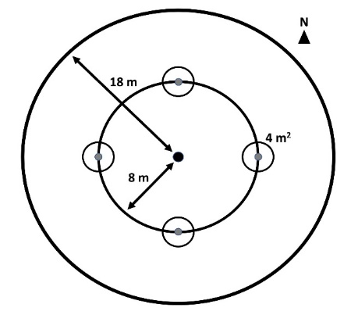

**b**

**Figure 1.** A) Map of southeast Michigan, showing the locations of the seven parks where forest stands were surveyed. B) Plot design, showing the 18 m radius main plot, the 8 m radius nested subplot, and the four 4 m2 area microplots located in cardinal directions.

Ash abundance and health

To assess the abundance and health of ash, canopy ash trees (≥10 cm diameter at breast height, DBH) were surveyed within the entire 18 m radius main plots, understory ash trees (2.5-10 cm DBH) and living ash saplings (≥137 cm in height but <2.5 cm DBH) were surveyed within the central 8 m radius subplots, and ash seedlings (<137 cm in height) were surveyed within the 4 m2 microplots. All seedlings were checked for the presence of cotyledons which would indicate they were newly germinated (Klooster et al. 2014). Ash seedlings were counted in two height categories, <25 cm and >25 cm, and the percentage cover of ash seedlings in microplots was estimated (Klooster et al. 2014).

When present, canopy and understory ash (>2.5 cm DBH) were assessed individually for DBH, species, and health. All DBH measurements were taken at a height of 137 cm (Ward et al. 2021). Due to difficulties in distinguishing green and white ash, species designations were grouped into three categories: 1) black ash; 2) all other species of ash, including white ash, green ash, and potentially pumpkin ash (*Fraxinus profunda*); and 3) unknown ash species because the tree was dead. After recording ash species, the tree was checked for signs and symptoms of EAB, including the presence of D-shaped emergence holes, woodpecker predation marks, bark splitting, epicormic sprouts, and basal sprouts. Furthermore, the canopy condition was rated using a 1 to 5 scale, where 1 represented a healthy canopy, 5 represented complete defoliation of the canopy (possibly still with living epicormic sprouts), and 2-4 represented increasing stages of decline (Smith 2006, Klooster et al. 2014, Knight et al. 2014). For statistical analyses, we simplified the canopy condition variable into two binary variables, *ash tree decline* and *ash tree death*. *Ash tree decline* was coded as 1 if the canopy condition showed any signs of decline (i.e. if canopy condition ≥ 2) and 0 if the canopy condition = 1. *Ash tree death* was coded as 1 if canopy condition = 5, and 0 otherwise (adapted from Hoven et al. 2020).

EAB trapping

In 2024, we used purple-prism traps and multi-funnel traps to assess EAB presence at six of the seven study parks (all except Hudson Mills Metropark, Table S2). Two purple-prism traps were installed at each park, for a total of 12 prism traps. Additionally, three multi-funnel (Lindgren) traps were installed at one park, Pontiac Lake Recreation Area. Traps were hung on or near the biggest ash trees that could be found in preliminary site visits. Traps were installed between May 29 and June 5, 2024 (627-734 GDD, base 50 °F, single sine method), and removed between July 23 and July 25, 2024 (1733-1770 GDD) (“Online Phenology and Degree-day Models” 2022). Purple prism traps used standard purple (“Coroplast purple”) colored board coated with glue (TAD Insect Trap Coating, Great Lakes IPM). Traps were hung at varying heights and near ash of varying size classes, depending on what was found at a park (Table S2). All traps were lured with Manuka oil and a fresh lure was installed halfway through the summer, between June 25 and July 3 (1146-1283 GDD). All buprestid beetles were removed from purple prism traps monthly, and from multi-funnel traps weekly, and EAB was identified and sexed (Parsons 2008).

Parasitoid sampling

In 2024, yellow pan traps were used to determine whether EAB’s introduced biological control agents were present at one of the parks, Pontiac Lake Recreation Area. Plot 53 at Pontiac Lake (Transect: M, Hydrology: mesic) was chosen because initial visits showed large numbers of regenerating ash. Some of the common plant species growing near the trunks of regenerating ash trees included spicebush (*Lindera benzoin*), bittersweet (*Celastrus orbiculatus*), Virginia creeper (*Parthenocissus quinquefolia*), and dogwood (*Cornus* sp.). A yellow pan trap was composed of two nested yellow plastic bowls attached to the trunk of a small ash tree and filled with a collection liquid (USDA–APHIS/ARS/FS 2021). The USDA design was modified by using polypropylene webbing straps instead of nails to attach to the tree (Figure S2). On June 4, 2024, 15 traps were attached at a height of 5-6 feet to small green or white ash trees with diameters between 3.2 and 9.6 cm DBH (Table S3). The collection liquid was 20% propylene glycol in water, with 1 drop of unscented dish soap. Traps were collected weekly until August 8, 2024, by pouring the collection liquid through a fine mesh paint filter (listed as 190 micron, actually ~300 micron = 0.3 mm), and rinsing with distilled water. As EAB’s introduced egg parasitoid *Oobius agrili* is 0.95 mm long (Zhang et al. 2005), a 0.3 mm mesh size should be sufficient to collect most *Oobius agrili* (although a smaller mesh would be ideal). Paint filters were cooled on ice within 30 minutes and frozen within 1 day (USDA–APHIS/ARS/FS 2021).

To sort trap contents, a paint filter was placed into a petri dish and 70% isopropanol in distilled water was added. All arthropods, except for thrips, springtails, mites, and small (< 1 mm) insect larvae, were counted and sorted into broad taxa. All Hymenoptera except Symphyta were sorted to superfamily level. Within the Ichneumonoidea, the families Ichneumonidae and Braconidae were distinguished. Within Chalcidoidea, the families Mymaridae and Encyrtidae were distinguished. Furthermore, the four introduced biological control agents of emerald ash borer were searched for, which are *Tetrastichus planipennisi* (Chalcidoidea: Eulophidae: Tetrastichinae), *Spathius galinae* and *S. agrili* (Ichneumonoidea: Braconidae: Doryctinae) and *Oobius agrili* (Chalcidoidea: Encyrtidae). Parasitoids were identified using the USDA Guidelines (USDA–APHIS/ARS/FS 2021) before being confirmed by expert identification (Toby Petrice, personal communication).

Vegetation survey in hydric transects

In 2025, to investigate which species of trees are found in the hydric plots, canopy trees (here defined as ≥12.5 cm DBH) and understory trees (2.5-12.5 cm DBH) were counted in the 18 m radius main plot and the 8 m radius subplot, respectively. The threshold between understory and canopy was set at 12.5 cm to be consistent with previous studies (Klooster et al. 2014, Smith et al. 2015). Only the 10 transects (30 plots) classified as hydric were surveyed. Trees were identified to species if possible and rated as living or dead (dead trees could still have living epicormic sprouts). Trees that divided into two or more branches below breast height (137 cm) were considered as the same tree and were counted if their sum of diameters was greater than the threshold (12.5 cm for the main plot or 2.5 cm for the subplot). Stems putatively connected below ground by root systems were considered as separate trees (Abella et al. 2019). Ash (*Fraxinus*) trees were counted in 2024, so only non-ash trees were counted in 2025. Although ash trees in the 10-12.5 cm DBH range were counted in the main plot in 2024, these ash trees did not meet the 12.5 cm threshold and were not included in the results for the tree survey. The shrubs poison sumac (*Toxicodendron vernix*), autumn olive (*Eleagnus umbellata*), spicebush (*Lindera benzoin*), and winterberry (*Ilex verticillata*) were not recorded in the DBH survey but were instead quantified using a visual survey of percentage cover. Percentage cover was estimated for the aforementioned shrub species, as well as for glossy buckthorn (*Frangula alnus*), graminoids (grasses, cattails, and sedges), skunk cabbage (*Symplocarpus foetidus*), ferns, and standing water. Percentage cover was estimated for each of these categories by standing at 8 m in the NE, SE, SW, and NW quadrants of the 18 m radius plot. The four estimates for each cover type were averaged for a plot-level estimate.

Statistical analysis

Counts of ash canopy and understory trees, non-ash canopy and understory trees, ash saplings, and ash seedlings were each summed across the three plots in a transect. Density was calculated by dividing the count by the area over which they were counted. For canopy and understory trees, density of standing dead trees (canopy condition = 5) was calculated separately from density of living trees (canopy condition < 5). Basal area was calculated for living canopy and understory trees using the formula Σ(π*(d/2)2), where d is the DBH of each individual tree stem (Hoven et al. 2020). Multiple stems of a single tree were considered individually for basal area calculations but were considered as the same tree for tree counts.

The existing categorization of transects (n=37) by hydrological class (xeric: 19 transects, mesic: 8 transects, hydric: 10 transects, Table S1) was used to test whether the abundance of ash differs based on hydrology. The response variables were number of short ash seedlings (count), number of tall ash seedlings (count), mean percentage cover of ash seedlings (continuous), number of ash saplings (count), and number of living understory ash trees (count). Due to a low number of observations, the number of canopy ash (≥10 cm DBH) was not tested statistically. A separate model was created for each response variable. Hydrological class (xeric, mesic, or hydric) was treated as the fixed effect predictor and park where transect was located as random intercepts to account for unique site conditions at each of the seven parks. For each count response variable, a Poisson generalized linear mixed-effects model (GLMM) with a log link function was implemented using the package ‘lme4’ (Bates et al. 2015) in R (R Core Team 2024). The package ‘DHARMa’ was used to determine if the observed data was adequately modelled by the GLMM (Hartig 2024). Whenever the Poisson GLMM was determined to be overdispersed, a new model was created using the negative binomial error structure. This was implemented using the ‘lme4’ and ‘MASS’ (Venables et al. 2002) packages in R. The residuals of the negative binomial GLMM were similarly examined to verify model fit. Furthermore, the Akaike Information Criterion (AIC) was compared between the Poisson and negative binomial models to verify improvement in fit. The models for number of saplings and number of understory trees were singular fits, so the random effect of park for these response variables was dropped. The mean percentage cover of ash seedlings is continuous, so a linear mixed effects model with normally distributed residuals was used. The mean percentage cover was transformed using the function f(x)=ln(x+1) in order to satisfy the assumption of homogeneity of variances. For all response variables, the R package ‘car’ (Fox and Weisberg 2019) was used to test for overall differences between hydrological classes, and Tukey contrasts were calculated using the R package ‘emmeans’ (Lenth 2024).

To test the hypothesis that ash tree diameter would be positively correlated with signs and symptoms of EAB attack, binomial regression was performed. Specifically, generalized linear mixed-effects models with binomial error structure and logit link functions were implemented using the package ‘lme4’ (Bates et al. 2015). The binary (y/n) response variables tested were *woodpecker predation marks*, *bark splitting*, *epicormic sprouts*, *basal sprouts*, *ash tree decline*, and *ash tree death*. The fixed effect predictor variable was always tree diameter at breast height (DBH). Plot was included as a random intercept to account for non-independence of trees in a plot. A Z-test was used to test the null hypothesis of no relationship between DBH and the EAB symptom. For our analysis, understory and overstory ash trees were pooled, and any tree was excluded if it belonged to a plot where less than 10 trees were found, which yielded a sample size of 283 trees (a cutoff of 5 trees in a plot was also tested and did not change the direction or significance of the results, Table S4). To assess the accuracy of the models, trees were binned into increments of 1 cm diameter, and the proportion of trees in each bin showing the EAB symptom was calculated. A model was judged as a good fit if the model trendline passed through the proportions for each bin.

**Results:**

In our survey of the 37 transects, we found ash (*Fraxinus*) seedlings in all but one transect. We found 2981 ash seedlings, 1037 ash saplings, 276 living and 54 dead standing understory ash trees, and 7 living and 2 dead standing canopy ash trees. Of the ash seedlings, none within the 444 microplots we measured had cotyledons, indicating that new germination of ash seedlings is extremely uncommon. We did observe two individual ash seedlings with cotyledons in 2025 at Island Lake, and in 2024 we observed isolated examples of ash seed production by four trees in the vicinity our study plots. Three out of four were black ash in hydric plots, and the diameter of the three seed-producing black ash trees ranged from 6.57 cm to 11.5 cm.

In our 2024 EAB trapping survey, the 12 prism traps caught a total of 18 EAB adults over the ~2 month trapping period (Figure S3). Most of the EAB individuals captured were from Kensington Metropark, but EAB was detected at all parks which were investigated except for Proud Lake (no traps were placed at Hudson Mills). Although prism traps did not recover EAB at Proud Lake, EAB exit holes were found on ash trees at the park. The three multifunnel traps at Pontiac Lake caught a total of 6 EAB adults.

Between June 4 and August 8, 2024, the 15 yellow pan traps caught a total of 1537 Hymenoptera, 1074 Diptera, 1163 Hemiptera, 77 Lepidoptera, 277 Coleoptera, and 152 other arthropods. A total of three introduced biological control agents were detected, including *Spathius galinae* (3 individuals collected), *Oobius agrili* (2 individuals), and *Tetrastichus planipennisi* (2 individuals).

Ash seedlings (<137 cm in height):

The average density of ash seedlings at the transect level ranged from 0 to 5.4 stems/m2 (0-54000 stems/ha), with an average of 1.65 stems/m2 (16500 stems/ha). Number of short ash seedlings (<25 cm height) averaged 0.88 stems/m2 and varied by hydrological class (χ2=12.6, 2 df, p=0.002). Hydric transects had lower numbers of short seedlings than mesic (Z=3.4, p=0.002) and xeric (Z=2.9, p=0.012) transects, while differences between mesic and xeric transects were not statistically significant (Fig. 2A). Number of tall ash seedlings (25-137 cm height) averaged 0.78 stems/m2 and differed by hydrological class (χ2=19.1, p<0.001), with hydric transects having lower numbers than either mesic (Z=4.3, p<0.001) or xeric (Z=3.3, p=0.003) transects (Fig. 2A). Mean percentage cover of ash seedlings at the transect level ranged from 0% to 38.1%, with an average of 10.7% across all transects. In mesic and xeric transects, the percentage cover of ash seedlings averaged 16.6% and 12.3%, respectively, but hydric transects had only 3.0% ash seedling cover on average. Statistics supported these trends, with percentage cover of ash seedlings varying by hydrological class (χ2=17.7, p<0.001), and hydric transects having significantly lower percent cover of ash seedlings than mesic (t=3.8, p=0.002) and xeric transects (t=3.3, p=0.006).

Ash saplings (≥137 cm in height and <2.5 cm DBH):

The density of ash saplings at the transect level ranged from 0 to 0.539 stems/m2 (0-5390 stems/ha), with an average of 0.046 stems/m2 (460 stems/ha). Any differences in number of saplings based on transect hydrological class were not significant (χ2=0.26, p=0.88) (Fig. 2B).

Ash trees (≥ 2.5 cm DBH) :

A total of 330 understory ash trees (2.5-10 cm DBH) were found in the subplots. Of these, 276 were living (canopy condition ≠ 5), while 54 were dead and standing. The density of living understory ash trees at the transect level ranged from 0 to 1193.7 trees/ha, with a mean of 123.7 trees/ha. The number of living understory ash trees varied by hydrological class (χ2=14.6, p=0.001). Hydric transects had more understory ash trees than xeric transects (Z=3.7, p=0.001) and marginally more understory ash trees than mesic transects (Z=2.2, p=0.078) (Fig. 2C). Of the 330 understory ash trees, 131 were identified as being green, white, or pumpkin ash, while 178 were identified as black ash, and 21 were unidentified *Fraxinus* (Figure S1). Only 9 canopy ash trees (≥ 10 cm DBH) were found in all the plots, of which 7 trees were living. Living canopy ash trees within the plots ranged in diameter from 10.3 cm DBH to 12.4 cm DBH. The basal area of living ash trees (all ash ≥ 2.5 cm DBH and canopy condition ≠ 5) at the transect level ranged between 0 and 2.60 m2/ha, with an average of 0.24 m2/ha.

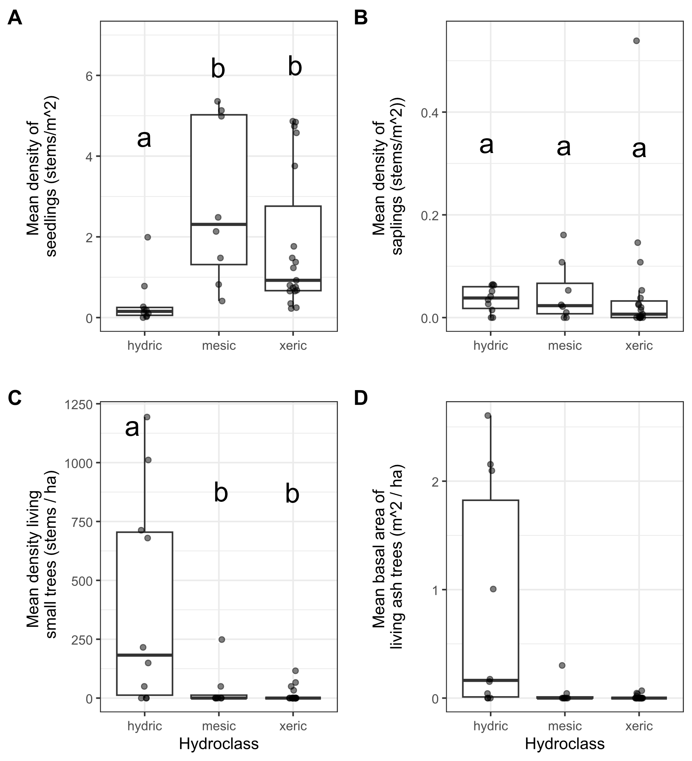

**Figure 2.** Ash occurrence in 37 transects in the Upper Huron River Watershed in southeast Michigan. The x-axis represents the soil hydroclass of the transect. Data points (transects) were overlayed on boxplots, with some horizontal jittering added. Lowercase letters above bars indicate statistically significant differences at α=0.05. A) Mean density of ash seedlings (all ash with height < 1.37 m; short and tall seedling categories were combined for the graph), B) mean density of ash saplings (height ≥ 1.37 m and DBH < 2.5 cm), C) mean density of living understory ash trees (2.5 cm ≤ DBH < 10 cm), D) mean basal area of all living ash trees (DBH ≥ 2.5 cm).

**Table 1.** Density (± standard error) of living ash (*Fraxinus*) regeneration in hydric (10 transects), mesic (8 transects), and xeric (19 transects) forests in the Upper Huron River Watershed in Southeast Michigan, USA. Only living trees are tabulated here. Data was collected in 2024 (97 plots) and 2025 (14 plots).

|  |  |  |
| --- | --- | --- |
| Size class | Hydrology class | Ash ha-1 |
| Short seedlings (<25 cm tall) | Hydric | 1,334 ± 952 |
|  | Mesic | 15,420 ± 4,920 |
|  | Xeric | 9,895 ± 2,458 |
| Tall seedlings (25-137 cm tall) | Hydric | 2,381 ± 994 |
|  | Mesic | 13,085 ± 2,563 |
|  | Xeric | 8,351 ± 1,625 |
| Saplings (>137 cm tall and <2.5 cm DBH) | Hydric | 360 ± 79 |
|  | Mesic | 472 ± 205 |
|  | Xeric | 517 ± 286 |
| Understory trees (2.5 – 10 cm DBH) | Hydric | 401 ± 145 |
|  | Mesic | 37 ± 31 |
|  | Xeric | 14 ± 7 |
| Canopy trees (>10 cm DBH) | Hydric | 2 ± 2 |
|  | Mesic | 0 |
|  | Xeric | 0 |

Signs and symptoms of EAB

Of the symptoms of EAB, bark splitting was the most common and was found on 193 (57%) ash trees (DBH ≥ 2.5 cm). Epicormic sprouts were found on 122 (36%) ash trees. Basal sprouts were found on 54 (16%) ash trees, while woodpecker predation marks were found on 46 (14%) ash trees. Out of a total of 338 trees, 229 (68%) had canopy condition=1 (meaning they were healthy), 33 (10%) had canopy condition=2, 13 (4%) had canopy condition=3, 7 (2%) had canopy condition=4, and 55 (16%) had canopy condition=5 (meaning they had a dead canopy). The D-shaped emergence holes from EAB were observed on a low percentage of ash trees, with only 8 trees (2%) recorded with exit holes.

Relationship between ash tree diameter and EAB symptoms

The presence of woodpecker predation marks was positively correlated with tree diameter (DBH), with a 1 cm increase in DBH increasing the odds of woodpecker marks by a factor of 1.24 (Z=2.46, p=0.013) (Figure 3A). Similarly, presence of epicormic sprouts was positively correlated with DBH, with a 1 cm increase in DBH increasing the odds of epicormic sprouts by a factor of 1.31 (Z=3.49, p<0.001) (Figure 3C). The presence of canopy foliage decline was positively correlated with DBH, such that a 1 cm increase in DBH increased the odds of canopy decline by a factor of 1.22 (Z=2.89, p=0.004) (Figure 3F). The relationship between DBH and bark splitting (Z=1.64, p=0.102), presence of basal sprouts (Z=1.16, p=0.245), and tree death (Z=0.21, p=0.831) were not significant (Figure 3, B, D, and E).

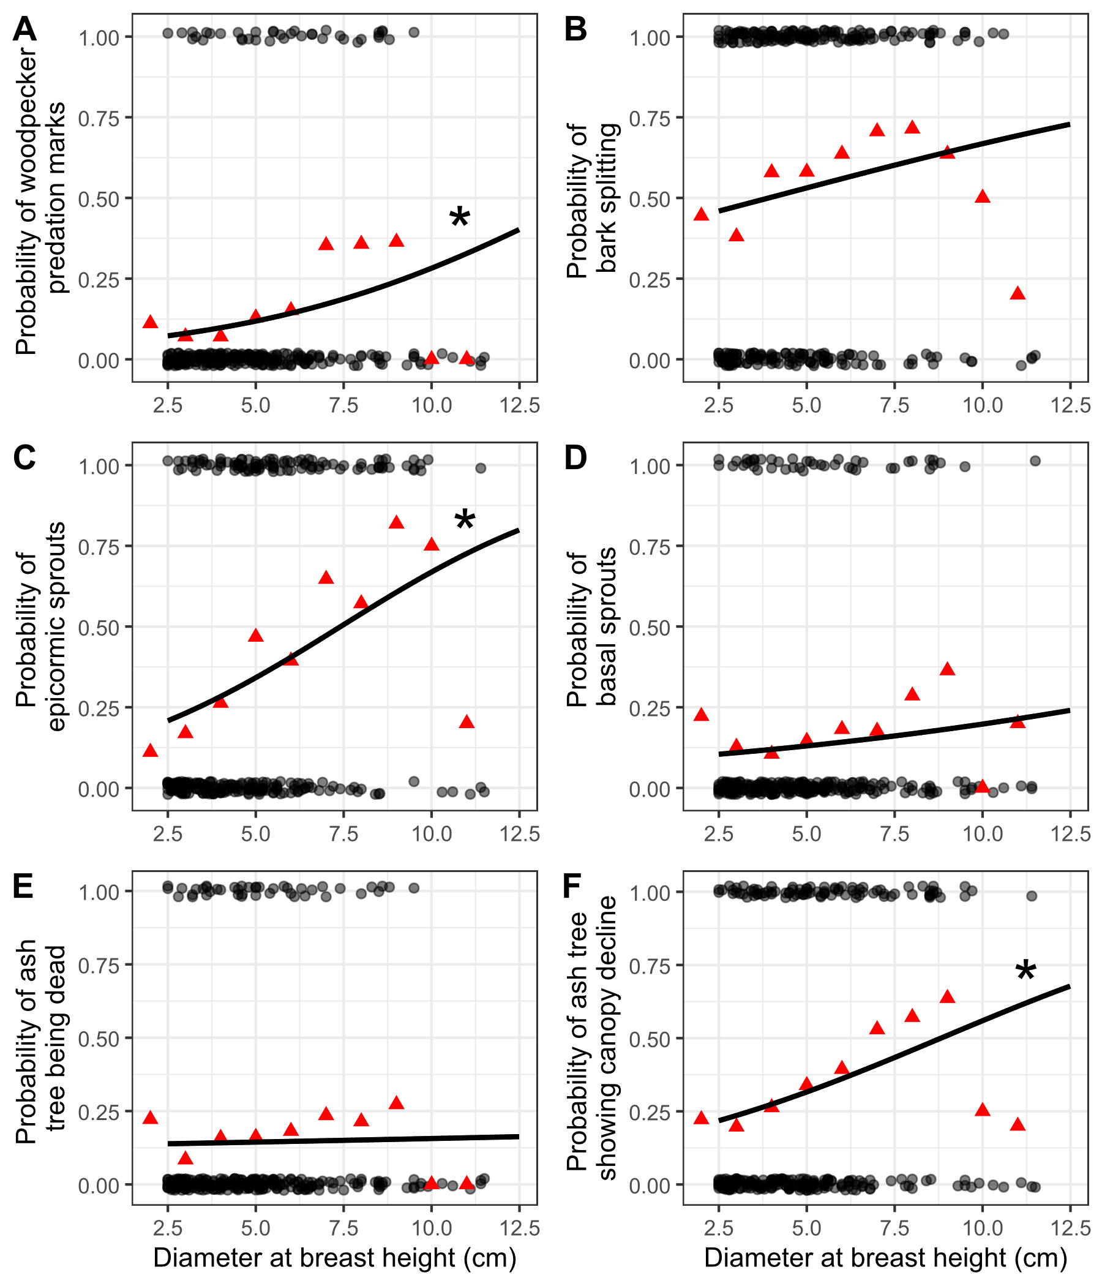

**Figure 3.** The presence or absence of symptoms of EAB plotted against tree diameter at breast height (DBH) for 283 trees in 10 forest plots. Grey circles are individual trees, which are plotted as y=1 for presence or y=0 for absence (points were vertically jittered slightly). Black line shows the overall fitted model, disregarding each specific random intercept for each plot. Asterisk next to the lines for woodpecker predation marks, epicormic sprouts, and canopy decline indicate a slope significantly different from zero. Red triangles show the proportion of trees that have the symptom within a DBH bin. For E, tree death is defined as having a canopy condition of 5. For F, canopy decline is defined as having a canopy condition between 2-5 (minor to complete defoliation).

Vegetation in hydric stands

We found 1030 canopy trees (≥ 12.5 cm DBH) in the 10 hydric transects, of which 810 were living and 220 were dead standing trees. In the understory (2.5 ≤ DBH < 12.5 cm), we found 792 trees, of which 638 were living and 154 were dead. The basal area of living trees in the canopy and understory averaged 21.1 m2/ha and 2.8 m2/ha, respectively. We found 18 genera of trees in the hydric transects (Tables 2-5). The most common species in the canopy were *Acer saccharinum* (303 living), *Ulmus* sp. (128 living), and *Tilia americana* (122 living). The genus *Acer* often dominated the canopy layer in hydric transects (Figure 4A). The most common species in the understory were *Carpinus caroliniana* (124 living), *Fraxinus nigra* (122 living), and *Fraxinus pennsylvanica* (possibly with some *F. americana* and *F. profunda*, 112 living). The genera *Ulmus*, *Carpinus*, and *Frangula* were more important in the understory than in the canopy layer, whereas *Quercus* and *Populus* were more important in the canopy layer (Figure 4).

Of the understory cover types estimated in hydric plots, graminoids, skunk cabbage, and spicebush had the highest percent cover values (Table 6). The invasive species glossy buckthorn had a low mean percent cover of 3.6%.

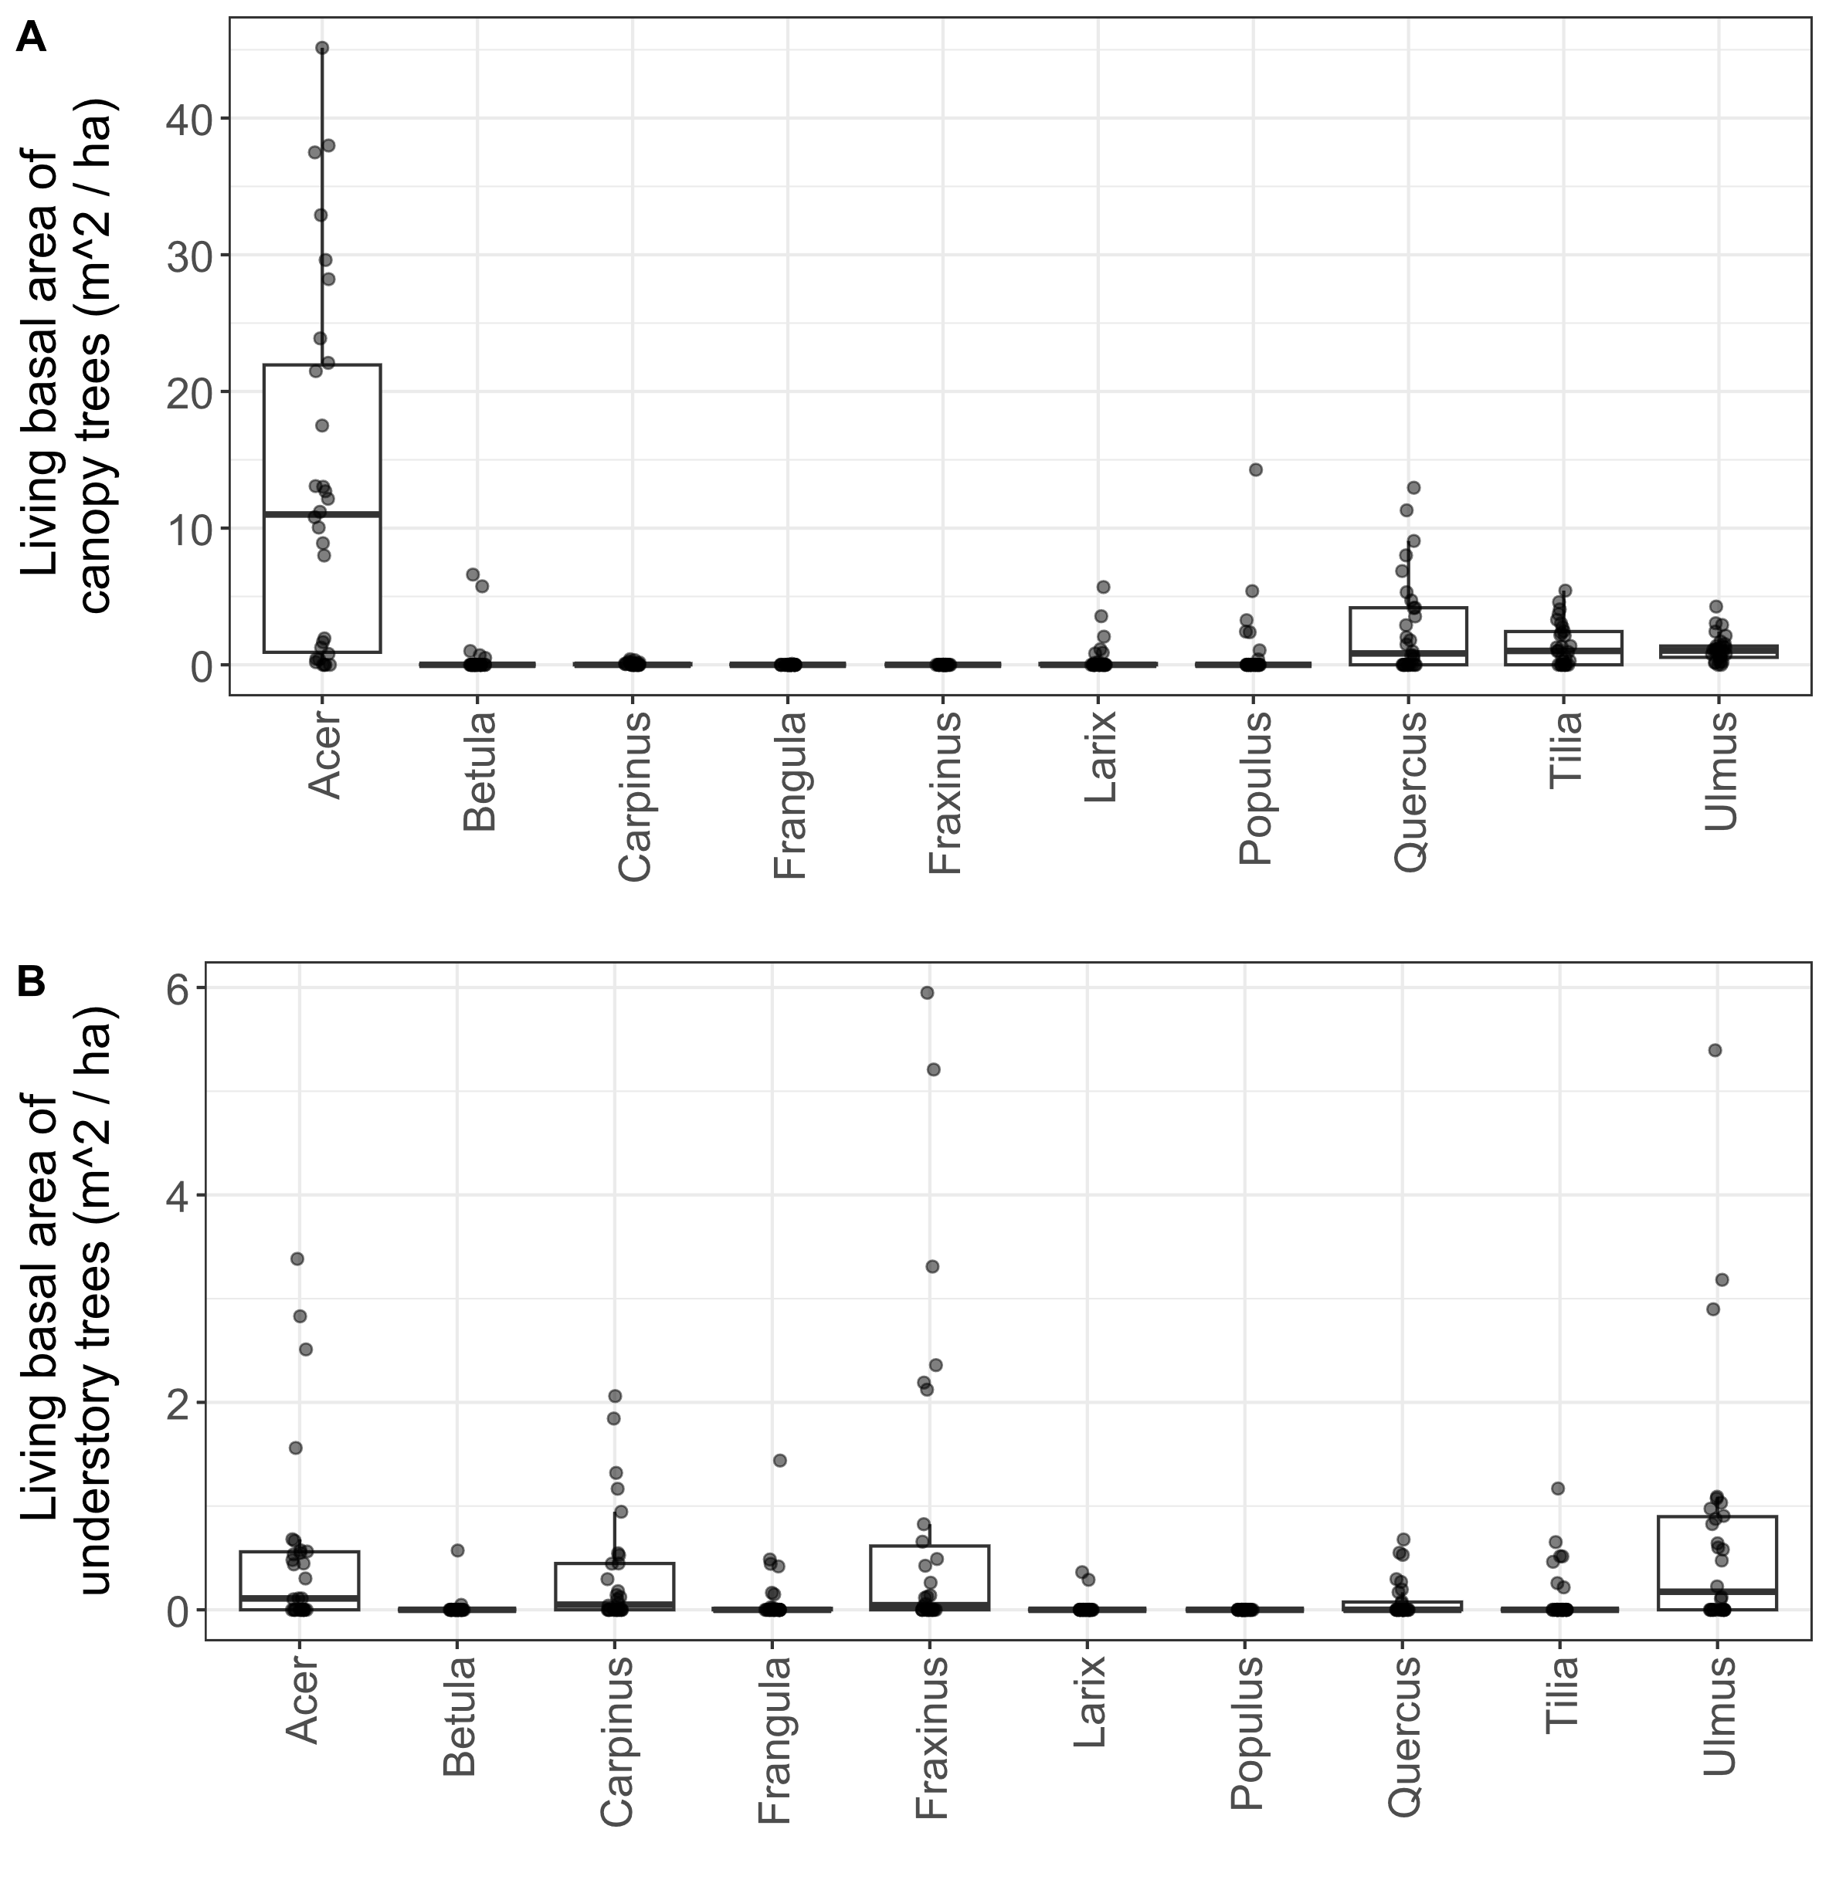

**Figure 4.** Basal area of living trees in 10 hydric transects (30 plots). Each dot represents a single plot. A) Canopy trees (≥ 12.5 cm DBH); B) understory trees (2.5-12.5 cm DBH). Tree genera were only included in the graph if their mean basal area was in the top seven for either canopy or understory trees.

**Table 2**. Relative density and relative dominance of tree genera found in the 4 hydric transects (12 plots) at Indian Springs Metropark. Only living trees are counted. Canopy trees are ≥12.5 cm DBH, while understory trees are 2.5-12.5 cm DBH. A total of 294 living canopy trees were counted in the main plots and 172 living understory trees were counted in the subplots at Indian Springs. Zeros indicate a value less than 0.5% while dashes indicate absence. Shrub species were not counted.

|  |  |  |  |  |
| --- | --- | --- | --- | --- |
|  | Relative density, % | | Relative dominance, % | |
| Genus | Canopy | Understory | Canopy | Understory |
| *Acer* | 50 | 12 | 79 | 17 |
| *Betula* | - | - | - | - |
| *Carpinus* | 6 | 27 | 1 | 17 |
| *Carya* | - | - | - | - |
| *Cornus* | - | - | - | - |
| *Fagus* | 1 | 1 | 2 | 2 |
| *Frangula* | - | 1 | - | 0 |
| *Fraxinus* | - | 33 | - | 22 |
| *Juniperus* | - | - | - | - |
| *Larix* | 0 | - | 0 | - |
| *Ostraya* | 1 | 2 | 0 | 1 |
| *Populus* | 1 | - | 1 | - |
| *Prunus* | - | 1 | - | 0 |
| *Quercus* | 7 | 3 | 7 | 3 |
| *Rhamnus* | - | - | - | - |
| *Tilia* | 18 | 1 | 8 | 2 |
| *Ulmus* | 16 | 21 | 4 | 36 |
| *Viburnum* | - | - | - | - |

**Table 3.** Relative density and relative dominance of tree genera found in the 3 hydric transects (9 plots) at Island Lake Recreation Area. Only living trees are counted. Canopy trees are ≥12.5 cm DBH, while understory trees are 2.5-12.5 cm DBH. A total of 333 living canopy trees were counted in the main plots and 334 living understory trees were counted in the subplots at Island Lake. Zeros indicate a value less than 0.5% while dashes indicate absence. Shrub species were not counted.

|  |  |  |  |  |
| --- | --- | --- | --- | --- |
|  | Relative density, % | | Relative dominance, % | |
| Genus | Canopy | Understory | Canopy | Understory |
| Acer | 55 | 11 | 63 | 23 |
| Betula | - | - | - | - |
| Carpinus | 1 | 20 | 0 | 10 |
| Carya | 1 | 1 | 0 | 1 |
| Cornus | - | 0 | - | 0 |
| Fagus | 1 | 0 | 0 | 0 |
| Frangula | - | 10 | - | 6 |
| Fraxinus | - | 37 | - | 27 |
| Juniperus | - | - | - | - |
| Larix | - | - | - | - |
| Ostraya | - | 1 | - | 1 |
| Populus | 2 | - | 10 | - |
| Prunus | 1 | - | 1 | - |
| Quercus | 12 | 5 | 16 | 5 |
| Rhamnus | 0 | - | 0 | - |
| Tilia | 13 | 4 | 5 | 5 |
| Ulmus | 14 | 11 | 4 | 21 |
| Viburnum | - | - | - | - |

**Table 4.** Relative density and relative dominance of tree genera found in the 2 hydric transects (6 plots) at Kensington Metropark. Only living trees are counted. Canopy trees are ≥12.5 cm DBH, while understory trees are 2.5-12.5 cm DBH. A total of 105 living canopy trees were counted in the main plots and 29 living understory trees were counted in the subplots at Kensington. Zeros indicate a value less than 0.5% while dashes indicate absence. Shrub species were not counted.

|  |  |  |  |  |
| --- | --- | --- | --- | --- |
|  | Relative density, % | | Relative dominance, % | |
| Genus | Canopy | Understory | Canopy | Understory |
| Acer | 5 | 7 | 3 | 12 |
| Betula | 3 | - | 3 | - |
| Carpinus | - | 24 | - | 27 |
| Carya | 2 | - | 2 | - |
| Cornus | - | 3 | - | 1 |
| Fagus | - | - | - | - |
| Frangula | - | - | - | - |
| Fraxinus | - | - | - | - |
| Juniperus | 1 | - | 0 | - |
| Larix | 30 | 21 | 21 | 14 |
| Ostraya | 1 | - | 0 | - |
| Populus | - | - | - | - |
| Prunus | 1 | 3 | 0 | 4 |
| Quercus | 19 | - | 41 | - |
| Rhamnus | - | 3 | - | 1 |
| Tilia | 27 | 24 | 19 | 30 |
| Ulmus | 11 | 3 | 10 | 3 |
| Viburnum | 1 | 10 | 0 | 10 |

**Table 5.** Relative density and relative dominance of tree genera found in the 1 hydric transect (3 plots) at Proud Lake Recreation Area. Only living trees are counted. Canopy trees are ≥12.5 cm DBH, while understory trees are 2.5-12.5 cm DBH. A total of 78 living canopy trees were counted in the main plots and 102 living understory trees were counted in the subplots at Proud Lake. Zeros indicate a value less than 0.5% while dashes indicate absence. Shrub species were not counted.

|  |  |  |  |  |
| --- | --- | --- | --- | --- |
|  | Relative density, % | | Relative dominance, % | |
| Genus | Canopy | Understory | Canopy | Understory |
| Acer | 10 | 9 | 7 | 13 |
| Betula | 36 | 2 | 45 | 5 |
| Carpinus | - | 4 | - | 1 |
| Carya | - | - | - | - |
| Cornus | - | 1 | - | 0 |
| Fagus | - | - | - | - |
| Frangula | 1 | 14 | 0 | 6 |
| Fraxinus | - | 61 | - | 58 |
| Juniperus | - | - | - | - |
| Larix | 19 | - | 20 | - |
| Ostraya | - | - | - | - |
| Populus | - | - | - | - |
| Prunus | - | - | - | - |
| Quercus | - | - | - | - |
| Rhamnus | - | - | - | - |
| Tilia | - | - | - | - |
| Ulmus | 33 | 10 | 28 | 17 |
| Viburnum | - | - | - | - |

**Table 6.** Average percent cover (± SE) of understory cover types in 10 hydric transects (30 plots). Standard errors were calculated using n=30.

|  |  |  |  |  |
| --- | --- | --- | --- | --- |
| Cover type | Scientific name | Mean percent cover (%) ± SE | | |
| Water |  | 9.8 | ± | 2.6 |
| Graminoids | Poales | 52.7 | ± | 5.0 |
| Skunk cabbage | *Symplocarpus foetidus* | 37.6 | ± | 5.0 |
| Ferns |  | 16.5 | ± | 2.9 |
| Spicebush | *Lindera benzoin* | 19.2 | ± | 4.4 |
| Winterberry | *Ilex verticillata* | 5.7 | ± | 1.9 |
| Glossy buckthorn | *Frangula alnus* | 3.6 | ± | 1.2 |
| Poison sumac | *Toxicodendron vernix* | 2.1 | ± | 0.9 |
| Other woody shrubs | *Elaeagnus umbellata, Cornus* sp.*, Rosa* sp.*, Vaccinium* sp.*, Corylus* sp., etc. | 5.0 | ± | 0.8 |

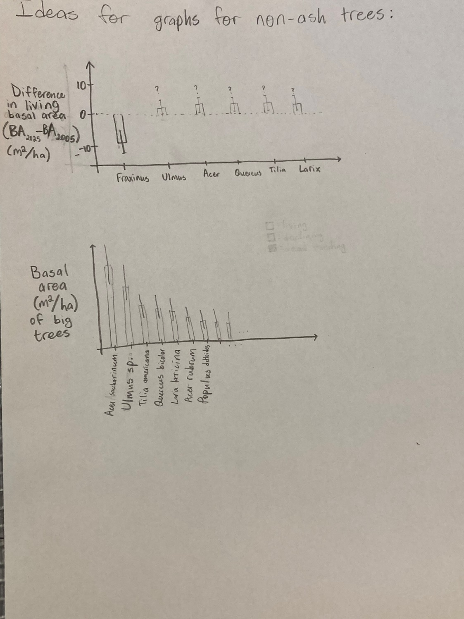

**Discussion**

In the discussion, I need to mention what are the key takeaways from the research. Here are some ideas:

-The ash seedling layer is still abundant in mesic and xeric forests, but not in hydric forests.

-Compare this result to other studies.

Fifteen years after the mortality of 99% of ash trees in forest stands in Southeast Michigan, we surveyed for the occurrence and health of ash regeneration, the presence of introduced natural enemies, and the abundance and basal area of non-ash trees.

We found that the amount of surviving ash regeneration strongly depended on soil hydrology, but patterns varied for seedlings vs. small trees. Ash seedlings (<1.37 m tall) were abundant in the understories of mesic and some xeric forests but were scarce in hydric forests. In contrast, living small ash trees (2.5-10 cm DBH) were often abundant in hydric forests, but were scarce in mesic and xeric forests. Thus, soil hydrology, or something that varies with soil hydrology, exerts a strong influence on ash regeneration in our study stands.

We found that even where ash seedlings were abundant, newly germinated seedlings were almost absent in 2024-2025 (we only found two individual seedlings with cotyledons at one site). After the near-complete elimination of ash trees > 2.5 cm in diameter in 2009 at our transects, production of viable seeds ceased and germination of new ash seedlings plummeted (Klooster et al. 2014). Fifteen years later, established ash seedlings persist, but the absence of new seeds means the ash seedling layer is not being replenished.

Although seed production by ash trees has not recovered, the number of living small ash trees has increased since the year of peak of ash mortality. In 2009, the densities of ash trees ≥ 2.5 cm DBH were 11.8, 1.6, and 0.6 trees/ha in hydric, mesic, and xeric transects, respectively (Klooster et al. 2014). In 2024-2025, densities have increased to 403, 37, and 14 living trees/ha, respectively. These surviving trees could still reach seed-producing size if they do not succumb to EAB. Our data suggests that the density of living ash trees in the 2.5-10 cm DBH range declined dramatically during peak EAB densities but then increased in the following decade. However, living basal area remains low, at 0.82, 0.04, and 0.01 m2/ha in hydric, mesic, and xeric transects in 2024-2025.

Multiple studies corroborate our result that ash regeneration varies based on site conditions. Most studies report high densities of ash seedlings in the understories of post-outbreak forests which previously had ash in the overstory. Even so, sites vary widely in the observed density of ash seedlings, which may be related to competition from sedges in hydric canopy gaps (Engelken et al. 2020) or differences in the number of surviving seed-producing ash trees (Morris et al. 2023). In one study, the densities of ash seedlings were lower in ash canopy gaps bordering streams and higher in the surrounding mixed forest, even though the canopy gaps previously had more canopy ash than the mixed forests (Engelken et al. 2020). This corroborates our result that ash seedling densities are higher in mesic transects than hydric transects.

Around 7 years after peak EAB densities, another study in Michigan similarly found that almost all ash trees >13 cm DBH had been killed, which significantly reduced the carrying capacity for EAB. The two sites had low densities of surviving small ash trees, but one site (Ocqueoc) had high densities of ash saplings (1,530 saplings/ha) (Siegert et al. 2021). Thus, substantial variability exists between sites in the abundance and size of ash regeneration.

In a study of Forest Inventory and Analysis (FIA) data, within the Lower Peninsula of Michigan and in northwest Ohio, ash trees in the 12.7-17.5 cm DBH class were dying at a faster rate than they were being recruited. Furthermore, within this area where EAB had been present longest, densities of living ash 2.54 cm – 12.7 cm diameter had decreased from one survey to the next (Ward et al. 2021). The story from our transects is similar but not identical. We found hardly any ash trees above 10 cm DBH in our plots, but we did find higher densities of ash in the 2.5-10 cm DBH range in hydric transects and evidence that these densities have increased since 2009. Thus, the FIA survey in 2013-2018 told the story of what happens to ash trees during peak EAB densities. Our data shows that numbers of ash in the 2.5 cm – 10 cm DBH range can begin to increase in post-outbreak forests, possibly due to lower EAB densities.

Questions for discussion:

-Why did we find ash recovery occurring faster in hydric forests?

-What factors might contribute to the success of ash trees in hydric forests?

Flooding tolerance, increased light, higher disturbance due to EAB, higher initial density of ash trees.

Multiple factors could explain our observation of higher numbers of ash understory trees in hydric transects, compared to mesic or xeric. Hydric transects tended to have sparser canopy cover than mesic or xeric transects, even prior to the impacts of EAB (Klooster 2012), a trend which is found in many swamp forests (Youngquist et al. 2017). This is likely related to the high water table, which creates anoxic conditions for tree roots (Kreuzwieser and Rennenberg 2014). This abiotic filter selects for trees with adaptations to waterlogging stress. Ash, particularly black ash, has adaptations which allow it to continue to pump water upwards through its xylem even when the soil is saturated with water (Telander et al. 2015). This tolerance to flooding makes ash a dominant genus in swamp forests in northeast North America. It could also increase the success of ash regeneration following canopy ash mortality. Hydric transects had both 1) higher sunlight levels due to the sparser canopy and 2) periodic flooding events which could have stressed non-ash sapling competitors. If canopy ash mortality caused an increase in mean water table height, as was shown in an ash clearcut and girdle experiment (Slesak et al. 2014), this would further favor plants that thrive in waterlogged conditions, such as ash regeneration.

-Seed germination of ash seedlings has almost entirely ceased.

-Compare to Klooster and Kashian

-Small green and black ash trees are abundant in some hydric forests, but not all.

-Compare to Siegert, Engelken, Abella, etc.

-Occurrence of epicormic sprouts, woodpecker predation marks, and defoliation all increase with increasing tree diameter from 2.5 cm to 10 cm. In the 8 – 10 cm DBH range, more than half of ash trees were showing epicormic sprouts, and more than half showed signs of canopy decline. However, a few trees above 10 cm DBH were found to be healthy and free from EAB signs and symptoms. The incidence of bark splits is almost 50% even at 2.5 cm DBH, indicating that EAB is attacking these small trees. The incidence of standing dead ash trees did not exhibit a significant relationship with DBH, indicating that ash tree mortality is occurring across a range of DBHs.

-Figure out what signals a tree to produce epicormic sprouts. Figure out how epicormic sprouts relate to captures of parasitoids.

-What stage of EAB do woodpeckers eat, and how much population control do they create?

We recovered three species of introduced natural enemies of EAB in our yellow pan trap sampling, but these introduced parasitoids of EAB were a minute fraction of the parasitoids captured on the trunks of small ash trees. We also found sizeable numbers of ichneumon wasps, platygastroid wasps, fairy wasps, and many others. What are the hosts of these parasitoids, and is it possible any of them are parasitizing EAB eggs or larvae? Does the distribution of different parasitoid superfamilies, along with the different orders of insects captured in the pan traps, indicate anything about the other biological processes occurring there? Do any of the parasitoids show seasonality?

-A result about what genera of trees, if any, have increased in basal area in hydric transects. And whether these genera are adapted to flooding stress, and whether they have any other threats (such as Dutch elm disease)

-A note about the ground cover of hydric sites, and what kinds of wildlife can be supported by shrub wetlands, sedge meadows, and spicebush-dominated areas.

-I think it’s important to note other potential factors that might be controlling the response of hydric forests to EAB. For one, the pH of the ground. Some hydric forests might have higher pH, hard water from groundwater flow. Other forests might have lower pH water from rainfall. White ash prefers soils with higher levels of Ca2+ and Mg2+ ions (Royo and Knight 2012), and it is conceivable that the other species of ash could also be affected by pH. Additionally, the forests on river floodplains might differ from those in swampy areas farther from rivers, because flowing water can have higher dissolved oxygen than standing water, and rivers can be a source of nutrients. The soil type could also influence forest response to EAB. Some swamp forests have mineral soils only a few feet below a muck layer, while other forests have organic peat soils.

-Yellow birch, *Betula alleghaniensis*, was only found at some of the parks, including Proud Lake. This species, as well as larch, *Larix laricina*, may indicate a forest that was previously dominated by northern conifer swamp in the past (Barnes 1976).

-

A paragraph about compensatory growth:

Because ash previously composed a large portion of total tree biomass in multiple forest types (Wagner and Todd 2015), the death of most overstory ash trees led to a reduction in living tree biomass. It is uncertain which trees, shrubs, or herbaceous plants will replace the space previously occupied by ash trees. In one scenario, the surrounding non-ash canopy trees increase their growth rate after the death of canopy ash, in a process called compensatory growth. Compensatory growth was observed in forests of Ohio between 2012 and 2014, where plots with higher amounts of declining ash trees had higher growth rates of non-ash trees (Hoven et al. 2020). A similar pattern was found using tree cores of red and silver maples (*Acer rubrum* and *Acer saccharinum*) in northeast Ohio (Costilow et al. 2017). However, another study which simulated EAB invasion in swamp forests of Upper Michigan found that the growth rates of non-ash overstory trees did not respond to the girdling or cutting of ash trees, at least for the first three growing seasons. Rather, herbaceous plants, including sedges (*Carex* sp.) and obligate wetland species, increased in the plots where canopy ash were killed (Davis et al. 2017). Similarly, in forests near Toledo, OH, basal area of non-ash trees has only partially compensated for the loss due to ash mortality, 14 years after EAB invasion (Abella et al. 2019).

A note about symptoms of EAB:

When examining the proportions of trees showing symptoms for groups binned by DBH, we noticed that the 9.5-10.5 cm group and the 10.5-11.5 cm group had lower-than-expected proportions of trees showing symptoms of EAB attack (Fig. 2, red triangles). Thus, the binomial GLMMs are not perfectly modelling the observed patterns. However, it must be noted that many of the ash in the 9.5-11.5 cm DBH range were from only one plot, plot 72 at Indian Springs.

**Supplementary Information**

We tested whether the arthropod community differed between ash trees showing canopy decline (indicating possible EAB infection) vs. ash trees with a full canopy. To do this, we categorized the 15 ash trees as either healthy (Canopy condition = 1, 9 trees) or declining (Canopy condition > 1, 6 trees). We used ash tree health (healthy vs. declining) as the predictor variable. Our response variables were the total number individuals of each taxonomic group caught between June 27 and August 1 (these intervals were fully sorted into taxonomic groups). Specifically, we tested any groups for which >= 15 individuals were caught in total, including total number of arthropods, Symphyta (sawflies), Dryinidae (pincer wasps), Formicidae (ants), Pompilloidea (spider wasps), Apoidea (bees and sphecoid wasps), Ichneumonidae, Braconidae, Diapriidae (shelf-faced wasps), Ceraphronoidea, Mymaridae (fairy wasps), Encyrtidae, Platygastroidea, Diptera (flies), Hemiptera (true bugs), Lepidoptera (moths), and Coleoptera (beetles). We ran a Mann-Whitney U-test for each response variable.

**Supplementary Tables**

**Table S1.** Plot locations for the 111 plots visited in this study. Each set of three plots makes up a transect. Each transect was given a hydrological class of xeric (19 transects), mesic (8 transects), or hydric (10 transects). The plot numbers go up to 114 because they skip 46-48, because transect K (Smith 2006) was not visited.

|  |  |  |  |  |  |  |
| --- | --- | --- | --- | --- | --- | --- |
| **Plot**  **number** | **Plot name** | **Park** | **Transect** | **Latitude** | **Longitude** | **Hydrological**  **class** |
| 1 | KENUPHD | Kensington | A | 42.53254195 | -83.6705388 | xeric |
| 2 | KENUPHD2 | Kensington | A | 42.53296724 | -83.67076505 | xeric |
| 3 | KENUPHD3 | Kensington | A | 42.53326356 | -83.67093244 | xeric |
| 4 | HMHD | Hudson Mills | AA | 42.37834666 | -83.91336117 | mesic |
| 5 | HMHD2 | Hudson Mills | AA | 42.3779638 | -83.91309216 | mesic |
| 6 | HMHD3 | Hudson Mills | AA | 42.37830402 | -83.91382332 | mesic |
| 7 | KENDRY | Kensington | B | 42.53544514 | -83.66722319 | xeric |
| 8 | KENDRY2 | Kensington | B | 42.53563361 | -83.66642756 | xeric |
| 9 | KENDRY3 | Kensington | B | 42.53588209 | -83.66709668 | xeric |
| 10 | HMDRY | Hudson Mills | BB | 42.37515735 | -83.91411337 | xeric |
| 11 | HMDRY2 | Hudson Mills | BB | 42.37474575 | -83.91429938 | xeric |
| 12 | HMDRY3 | Hudson Mills | BB | 42.37398156 | -83.91421887 | xeric |
| 13 | KENUP | Kensington | C | 42.53463699 | -83.66695495 | xeric |
| 14 | KENUP2 | Kensington | C | 42.53497995 | -83.66657034 | xeric |
| 15 | KENUP3 | Kensington | C | 42.53429542 | -83.66721965 | xeric |
| 16 | ILOPEN | Island Lake | CC | 42.49941418 | -83.7165664 | mesic |
| 17 | ILOPEN2 | Island Lake | CC | 42.50011316 | -83.71690408 | mesic |
| 18 | ILOPEN3 | Island Lake | CC | 42.49984426 | -83.71729405 | mesic |
| 19 | KENDRY3 | Kensington | D | 42.53784433 | -83.66665362 | xeric |
| 20 | KENDRY3A | Kensington | D | 42.53794168 | -83.66596685 | xeric |
| 21 | KENDRY3B | Kensington | D | 42.53727952 | -83.66639485 | xeric |
| 22 | ILLOW | Island Lake | DD | 42.49971912 | -83.71630958 | hydric |
| 23 | ILLOW2 | Island Lake | DD | 42.50085549 | -83.7166848 | hydric |
| 24 | ILLOW3 | Island Lake | DD | 42.49794685 | -83.71775494 | hydric |
| 25 | PLINT | Proud Lake | E | 42.5759159 | -83.52099242 | xeric |
| 26 | PLINT2 | Proud Lake | E | 42.57601569 | -83.52054316 | xeric |
| 27 | PLINT3 | Proud Lake | E | 42.57637225 | -83.52026922 | xeric |
| 28 | HLMAT | Highland | EE | 42.64473456 | -83.56669535 | xeric |
| 29 | HLMAT2 | Highland | EE | 42.64590976 | -83.56680506 | xeric |
| 30 | HLMAT3 | Highland | EE | 42.64686284 | -83.56915982 | xeric |
| 31 | PLDRYMAT | Proud Lake | F | 42.57578816 | -83.52318352 | xeric |
| 32 | PLDRYMAT2 | Proud Lake | F | 42.57577574 | -83.52399007 | xeric |
| 33 | PLDRYMAT2A | Proud Lake | F | 42.57635459 | -83.52182426 | xeric |
| 34 | PLCONF | Proud Lake | G | 42.57571524 | -83.52814029 | xeric |
| 35 | PLDRYMAT3 | Proud Lake | G | 42.57581763 | -83.52740826 | xeric |
| 36 | PLDRYMAT3A | Proud Lake | G | 42.57607392 | -83.52668128 | xeric |
| 37 | PLWET | Proud Lake | H | 42.5747667 | -83.54598723 | hydric |
| 38 | PLWET2 | Proud Lake | H | 42.57474279 | -83.54632682 | hydric |
| 39 | PLWET3 | Proud Lake | H | 42.57428658 | -83.54708265 | hydric |
| 40 | KENWET | Kensington | I | 42.53043348 | -83.67041583 | hydric |
| 41 | KENWET2 | Kensington | I | 42.53110591 | -83.66746124 | hydric |
| 42 | KENWET4 | Kensington | I | 42.53118814 | -83.66648081 | hydric |
| 43 | KENWET3 | Kensington | J | 42.53124676 | -83.66897599 | hydric |
| 44 | KENWET3A | Kensington | J | 42.53101609 | -83.66944111 | hydric |
| 45 | KENWET3B | Kensington | J | 42.53146534 | -83.6685188 | hydric |
| 49 | PONUP | Pontiac Lake | L | 42.67601991 | -83.48374379 | xeric |
| 50 | PONUP2 | Pontiac Lake | L | 42.67639534 | -83.48336561 | xeric |
| 51 | PONUP3 | Pontiac Lake | L | 42.67695181 | -83.48354417 | xeric |
| 52 | PONHD | Pontiac Lake | M | 42.67737591 | -83.4842027 | mesic |
| 53 | PONHD2 | Pontiac Lake | M | 42.67763539 | -83.48494077 | mesic |
| 54 | PONHD3 | Pontiac Lake | M | 42.67619344 | -83.48458083 | mesic |
| 55 | PONEAST | Pontiac Lake | N | 42.67628637 | -83.48161802 | xeric |
| 56 | PONEAST2 | Pontiac Lake | N | 42.67644003 | -83.48223133 | xeric |
| 57 | PONEAST3 | Pontiac Lake | N | 42.67655527 | -83.4827693 | xeric |
| 58 | PONRT | Pontiac Lake | O | 42.67697644 | -83.48225793 | xeric |
| 59 | PONRT2 | Pontiac Lake | O | 42.67847161 | -83.4821571 | xeric |
| 60 | PONRT3 | Pontiac Lake | O | 42.67796779 | -83.48337831 | xeric |
| 61 | ILRIP | Island Lake | P | 42.50511387 | -83.711563 | hydric |
| 62 | ILRIP2 | Island Lake | P | 42.50548015 | -83.71130397 | hydric |
| 63 | ILRIP3 | Island Lake | P | 42.50506543 | -83.71105671 | hydric |
| 64 | ILCC | Island Lake | Q | 42.49871458 | -83.71880034 | hydric |
| 65 | ILCC2 | Island Lake | Q | 42.49826164 | -83.71911588 | hydric |
| 66 | ILCC3 | Island Lake | Q | 42.49755544 | -83.7194028 | hydric |
| 67 | ISMATDRY | Indian Springs | R | 42.70259786 | -83.49652337 | mesic |
| 68 | ISMATDRY2 | Indian Springs | R | 42.70213825 | -83.49648848 | mesic |
| 69 | ISMATDRY3 | Indian Springs | R | 42.70223513 | -83.49584728 | mesic |
| 70 | ISLD | Indian Springs | S | 42.7016922 | -83.49741597 | hydric |
| 71 | ISLD2 | Indian Springs | S | 42.70129243 | -83.49740698 | hydric |
| 72 | ISLD3 | Indian Springs | S | 42.70142849 | -83.49779967 | hydric |
| 73 | ISMATDE | Indian Springs | T | 42.7035437 | -83.49463936 | xeric |
| 74 | ISMATDE2 | Indian Springs | T | 42.70375308 | -83.49415138 | xeric |
| 75 | ISMATDE3 | Indian Springs | T | 42.70278921 | -83.49360562 | xeric |
| 76 | ISRIP | Indian Springs | U | 42.70463303 | -83.49570897 | hydric |
| 77 | ISRIP2 | Indian Springs | U | 42.70481219 | -83.494821 | hydric |
| 78 | ISRIP3 | Indian Springs | U | 42.70487822 | -83.4940807 | hydric |
| 79 | ISOPEN | Indian Springs | V | 42.70480262 | -83.49706373 | mesic |
| 80 | ISOPEN2 | Indian Springs | V | 42.70388702 | -83.49893342 | mesic |
| 81 | ISOPEN3 | Indian Springs | V | 42.7045196 | -83.49803841 | mesic |
| 82 | HLMATFR | Highland | W | 42.6489291 | -83.55636056 | xeric |
| 83 | HLMATFR2 | Highland | W | 42.64858561 | -83.55689617 | xeric |
| 84 | HLMATFR3 | Highland | W | 42.64939898 | -83.55761483 | xeric |
| 85 | HLRIP | Highland | X | 42.64587606 | -83.55093888 | mesic |
| 86 | HLRIP2 | Highland | X | 42.64514371 | -83.55089568 | mesic |
| 87 | HLRIP3 | Highland | X | 42.64637211 | -83.55062169 | mesic |
| 88 | HLUP | Highland | Y | 42.6470476 | -83.55230573 | xeric |
| 89 | HLUP2 | Highland | Y | 42.64705538 | -83.55397741 | xeric |
| 90 | HLUP3 | Highland | Y | 42.6474566 | -83.55365762 | xeric |
| 91 | HMMAT | Hudson Mills | Z | 42.37824499 | -83.91166168 | xeric |
| 92 | HMMAT2 | Hudson Mills | Z | 42.37825474 | -83.91229145 | xeric |
| 93 | HMMAT3 | Hudson Mills | Z | 42.3787298 | -83.91267589 | xeric |
| 94 | PONNEW | Pontiac Lake | ZA | 42.67554541 | -83.48274071 | xeric |
| 95 | PONNEW2 | Pontiac Lake | ZA | 42.67584028 | -83.4830424 | xeric |
| 96 | PONNEW3 | Pontiac Lake | ZA | 42.67606664 | -83.48271281 | xeric |
| 97 | PONRD | Pontiac Lake | ZB | 42.67546355 | -83.4821069 | mesic |
| 98 | PONRD2 | Pontiac Lake | ZB | 42.67597751 | -83.48183457 | mesic |
| 99 | PONRD3 | Pontiac Lake | ZB | 42.67611495 | -83.4822095 | mesic |
| 100 | PONWH | Pontiac Lake | ZC | 42.67657235 | -83.48190157 | xeric |
| 101 | PONWH2 | Pontiac Lake | ZC | 42.67696268 | -83.48095924 | xeric |
| 102 | PONWH3 | Pontiac Lake | ZC | 42.67670871 | -83.48046038 | xeric |
| 103 | ISBR | Indian Springs | ZD | 42.70640403 | -83.49342124 | hydric |
| 104 | ISBR2 | Indian Springs | ZD | 42.70623663 | -83.4938222 | hydric |
| 105 | ISBR3 | Indian Springs | ZD | 42.70670773 | -83.49360969 | hydric |
| 106 | ISBRS | Indian Springs | ZE | 42.70572744 | -83.49386673 | hydric |
| 107 | ISBRS2 | Indian Springs | ZE | 42.70535737 | -83.49412394 | hydric |
| 108 | ISBRS3 | Indian Springs | ZE | 42.70514295 | -83.49498565 | hydric |
| 109 | ISWH | Indian Springs | ZF | 42.70282112 | -83.49624363 | mesic |
| 110 | ISWH2 | Indian Springs | ZF | 42.70256049 | -83.49579452 | mesic |
| 111 | ISWH3 | Indian Springs | ZF | 42.70249606 | -83.49513887 | mesic |
| 112 | KENNEW | Kensington | ZG | 42.53359794 | -83.67122473 | xeric |
| 113 | KENNEW2 | Kensington | ZG | 42.53386003 | -83.67146597 | xeric |
| 114 | KENNEW3 | Kensington | ZG | 42.5343776 | -83.6712658 | xeric |

**Table S2.** Trap locations for the 2024 purple-prism and multi-funnel traps installed to assess EAB presence.



**Table S3.** Yellow pan trap information for 2024 parasitoid sampling effort. All traps were within ~30 meters of the center tree for Plot 53 at Pontiac Lake Recreation Area.

|  |  |  |  |  |  |  |  |  |
| --- | --- | --- | --- | --- | --- | --- | --- | --- |
| **Trap number** | **DBH of ash (cm)** | **Canopy condition**  **(1-5)** | **EAB exit holes?** | **Woodpecker marks?** | **Ash bark splitting?** | **Epicormic sprouts?** | **Basal sprouts?** | **Canopy condition (binary)** |
| 101 | 3.2 | 3 | n | n | y | y | y | Declining |
| 102 | 5.2 | 1 | n | n | y | n | n | Healthy |
| 103 | 6.6 | 1 | n | n | y | y | n | Healthy |
| 104 | 7.2 | 1 | n | n | y | y | n | Healthy |
| 105 | 3.1 | 3 | y | n | y | y | y | Declining |
| 106 | 5.9 | 1 | n | n | y | n | n | Healthy |
| 107 | 3.6 | 1 | n | n | n | y | n | Healthy |
| 108 | 4.45 | 1 | n | n | y | n | n | Healthy |
| 109 | 7.2 | 1 | n | n | y | y | n | Healthy |
| 110 | 8.9 | 1 | n | n | n | n | n | Healthy |
| 111 | 4.6 | 4 | n | n | y | y | y | Declining |
| 112 | 6.7 | 3 | n | n | y | y | n | Declining |
| 113 | 9.6 | 2 | n | n | n | n | n | Declining |
| 114 | 4.2 | 1 | n | n | y | y | n | Healthy |
| 115 | 9.1 | 4 | n | y | y | y | y | Declining |

**Table S4.** Statistical results for the model of the relationship between ash tree diameter and symptoms of EAB. The slope coefficient is the fitted coefficient which is multiplied by tree diameter within the model. The 10-tree criterion is where ash trees were only included if they belonged to plots where 10 or more ash trees were found. The models using the 10-tree criterion have n=283 trees (in 10 plots), while the models using the 5-tree criterion have n=305 trees (in 13 plots). The p-value is the probability, under the assumption that the true slope is zero, that we would find a slope coefficient larger in absolute value than the observed slope coefficient. Rows are bolded if the p-values were found to be less than 0.05.

|  |  |  |  |  |  |  |
| --- | --- | --- | --- | --- | --- | --- |
| EAB Symptom | Slope coefficient for 10 tree criterion | Slope coefficient for  5 tree criterion | Z value for 10 tree criterion | Z value for 5 tree criterion | p value for 10 tree criterion | p value for 5 tree criterion |
| **Woodpecker marks** | **0.2151** | **0.20432** | **2.461** | **2.429** | **0.0139** | **0.0151** |
| Bark splitting | 0.11505 | 0.10739 | 1.635 | 1.515 | 0.102 | 0.130 |
| **Epicormic sprouts** | **0.27194** | **0.25571** | **3.491** | **3.379** | **0.00048** | **0.000728** |
| Basal sprouts | 0.09990 | 0.09968 | 1.162 | 1.204 | 0.245334 | 0.228457 |
| Ash tree death | 0.01897 | 0.01139 | 0.214 | 0.135 | 0.830708 | 0.892797 |
| **Ash tree decline** | **0.20223** | **0.17223** | **2.886** | **2.531** | **0.00391** | **0.011377** |

**Supplementary figures**

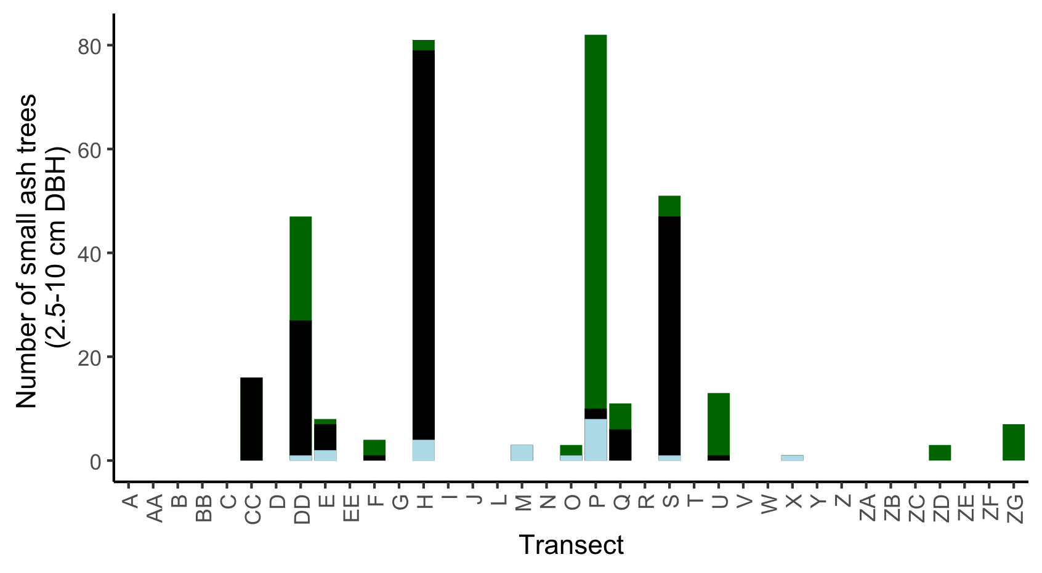

**Figure S1.** The total number of small ash trees (2.5 – 10 cm DBH) found in 37 transects in the Upper Huron River Watershed. Small ash of all canopy conditions are counted. Bars are shaded based on the proportion of each ash species that was found in a transect. Green represents green, white, and/or pumpkin ash; black represents black ash; light blue represents unknown ash species.

**Figure S2.** Yellow pan trap design using nested yellow bowls attached to a wooden stand and strapped to an ash tree.

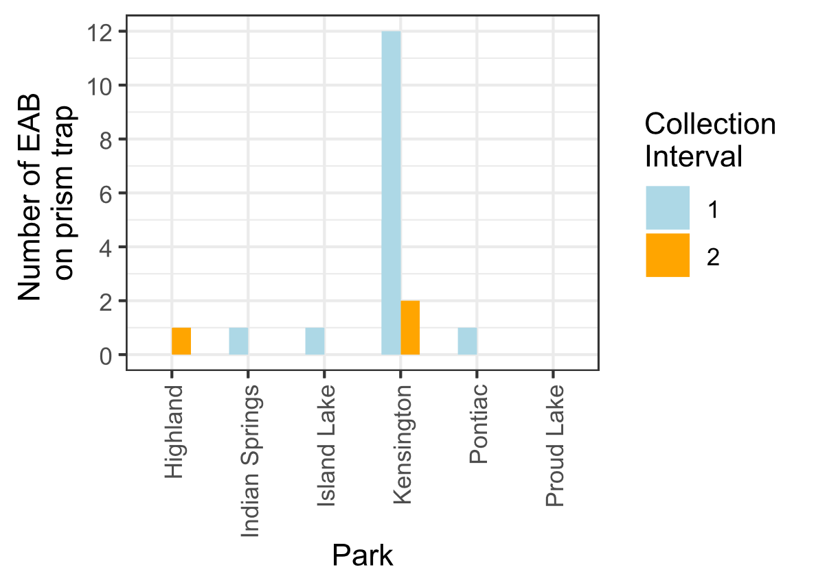

**Figure S3.** Captures of EAB adults from Prism traps in 2024. Collection interval 1 corresponds to June, while collection interval 2 corresponds to July.

**References:**

Abell, K. J., J. J. Duan, L. Bauer, J. P. Lelito, and R. G. Van Driesche. 2012. The effect of bark thickness on host partitioning between Tetrastichus planipennisi (Hymen: Eulophidae) and Atanycolus spp. (Hymen: Braconidae), two parasitoids of emerald ash borer (Coleop: Buprestidae). Biological Control 63:320–325.

Abella, S. R., C. E. Hausman, J. F. Jaeger, K. S. Menard, T. A. Schetter, and O. J. Rocha. 2019. Fourteen years of swamp forest change from the onset, during, and after invasion of emerald ash borer. Biological Invasions 21:3685–3696.

Abella, S. R., K. S. Menard, T. A. Schetter, and C. E. Hausman. 2024. Species and landscape variation in tree regeneration and 17 years of change in forested wetlands invaded by emerald ash borer. Forest Ecology and Management 557:121750.

Aker, S. A., R. B. De Andrade, J. J. Duan, and D. S. Gruner. 2022. Rapid Spread of an Introduced Parasitoid for Biological Control of Emerald Ash Borer (Coleoptera: Buprestidae) in Maryland. Journal of Economic Entomology 115:381–386.

Aubin, I., F. Cardou, K. Ryall, D. Kreutzweiser, and T. Scarr. 2015. Ash regeneration capacity after emerald ash borer (EAB) outbreaks: Some early results. The Forestry Chronicle 91:291–298.

Barnes, B. V. 1976. Succession in deciduous swamp communities of southeastern Michigan formerly dominated by American elm. Canadian Journal of Botany 54:19–24.

Bates, D., M. Mächler, B. Bolker, and S. Walker. 2015. Fitting Linear Mixed-Effects Models Using **lme4**. Journal of Statistical Software 67.

Burns, R., and B. Honkala. 1990. Silvics of North America: Volume 2, Hardwoods.

Costilow, K. C., K. S. Knight, and C. E. Flower. 2017. Disturbance severity and canopy position control the radial growth response of maple trees (Acer spp.) in forests of northwest Ohio impacted by emerald ash borer (Agrilus planipennis). Annals of Forest Science 74:10.

Davis, J. C., J. P. Shannon, N. W. Bolton, R. K. Kolka, and T. G. Pypker. 2017. Vegetation responses to simulated emerald ash borer infestation in *Fraxinus nigra* dominated wetlands of Upper Michigan, USA. Canadian Journal of Forest Research 47:319–330.

Duan, J. J., L. S. Bauer, K. J. Abell, M. D. Ulyshen, and R. G. Van Driesche. 2015. Population dynamics of an invasive forest insect and associated natural enemies in the aftermath of invasion: implications for biological control. Journal of Applied Ecology 52:1246–1254.

Duan, J. J., L. S. Bauer, and R. G. Van Driesche. 2017. Emerald ash borer biocontrol in ash saplings: The potential for early stage recovery of North American ash trees. Forest Ecology and Management 394:64–72.

Duan, J. J., J. R. Gould, N. F. Quinn, T. R. Petrice, B. H. Slager, T. M. Poland, L. S. Bauer, C. E. Rutledge, J. S. Elkinton, and R. G. Van Driesche. 2023. Protection of North American ash against emerald ash borer with biological control: ecological premises and progress toward success. BioControl 68:87–100.

Engelken, P. J., M. E. Benbow, and D. G. McCullough. 2020. Legacy effects of emerald ash borer on riparian forest vegetation and structure. Forest Ecology and Management 457:117684.

Fox, J., and S. Weisberg. 2019. An {R} Companion to Applied Regression. Sage, Thousand Oaks {CA}.

Gandhi, K. J. K., and D. A. Herms. 2010. Direct and indirect effects of alien insect herbivores on ecological processes and interactions in forests of eastern North America. Biological Invasions 12:389–405.

Hartig, F. 2024. DHARMa: Residual Diagnostics for Hierarchical (Multi-Level / Mixed) Regression Models. R.

Hoven, B. M., K. S. Knight, V. E. Peters, and D. L. Gorchov. 2020. Release and suppression: forest layer responses to emerald ash borer (Agrilus planipennis)-caused ash death. Annals of Forest Science 77:10.

Klooster, W., K. Gandhi, L. Long, K. Perry, K. Rice, and D. Herms. 2018. Ecological Impacts of Emerald Ash Borer in Forests at the Epicenter of the Invasion in North America. Forests 9:250.

Klooster, W. S. 2012. Forest Responses to Emerald Ash Borer-Induced Ash Mortality. PhD Thesis, The Ohio State University.

Klooster, W. S., D. A. Herms, K. S. Knight, C. P. Herms, D. G. McCullough, A. Smith, K. J. K. Gandhi, and J. Cardina. 2014. Ash (Fraxinus spp.) mortality, regeneration, and seed bank dynamics in mixed hardwood forests following invasion by emerald ash borer (Agrilus planipennis). Biological Invasions 16:859–873.

Knight, K. S., B. P. Flash, R. H. Kappler, J. A. Throckmorton, B. Grafton, and C. E. Flower. 2014. Monitoring Ash (Fraxinus spp.) Decline and Emerald Ash Borer (Agrilus planipennis) Symptoms in Infested Areas. General Technical Report, U.S. Department of Agriculture, Forest Service, Northern Research Station.

Kolka, R., A. D’Amato, J. Wagenbrenner, R. Slesak, T. Pypker, M. Youngquist, A. Grinde, and B. Palik. 2018. Review of Ecosystem Level Impacts of Emerald Ash Borer on Black Ash Wetlands: What Does the Future Hold? Forests 9:179.

Kreuzwieser, J., and H. Rennenberg. 2014. Molecular and physiological responses of trees to waterlogging stress. Plant, Cell & Environment 37:2245–2259.

Lenth, R. V. 2024. emmeans: Estimated Marginal Means, aka Least-Squares Means. R.

Lovett, G. M., C. D. Canham, M. A. Arthur, K. C. Weathers, and R. D. Fitzhugh. 2006. Forest Ecosystem Responses to Exotic Pests and Pathogens in Eastern North America. BioScience 56:395.

McCormick, J. F., and R. B. Platt. 1980. Recovery of an Appalachian Forest Following the Chestnut Blight or Catherine Keever-You Were Right! American Midland Naturalist 104:264.

McCullough, D. G. 2019. Challenges, tactics and integrated management of emerald ash borer in North America. Forestry: An International Journal of Forest Research 93:197–211.

Mech, A. M., K. A. Thomas, T. D. Marsico, D. A. Herms, C. R. Allen, M. P. Ayres, K. J. K. Gandhi, J. Gurevitch, N. P. Havill, R. A. Hufbauer, A. M. Liebhold, K. F. Raffa, A. N. Schulz, D. R. Uden, and P. C. Tobin. 2019. Evolutionary history predicts high‐impact invasions by herbivorous insects. Ecology and Evolution 9:12216–12230.

Megonigal, J. P., W. H. Conner, S. Kroeger, and R. R. Sharitz. 1997. Aboveground Production in Southeastern Floodplain Forests: A Test of the Subsidy-Stress Hypothesis. Ecology 78:370–384.

Morris, T. D., J. R. Gould, J. Drake, and M. K. Fierke. 2023. Status of ash forests and regeneration a decade after first detection of emerald ash borer infestation in New York state. Forest Ecology and Management 549:121464.

Murphy, T. C., R. G. Van Driesche, J. R. Gould, and J. S. Elkinton. 2017. Can Spathius galinae attack emerald ash borer larvae feeding in large ash trees? Biological Control 114:8–13.

Niinemets, Ü., and F. Valladares. 2006. Tolerance to Shade, Drought, and Waterlogging of Temperate Northern Hemisphere Trees and Shrubs. Ecological Monographs 76:521–547.

Online Phenology and Degree-day Models. 2022. . https://uspest.org/dd/model_app.

Palik, B. J., M. E. Ostry, R. C. Venette, and E. Abdela. 2012. Tree regeneration in black ash (Fraxinus nigra) stands exhibiting crown dieback in Minnesota. Forest Ecology and Management 269:26–30.

Parsons, G. 2008. Emerald Ash Borer: A guide to identification and comparison to similar species. Michigan State University Department of Entomology.

Perry, K., and D. Herms. 2019. Dynamic Responses of Ground-Dwelling Invertebrate Communities to Disturbance in Forest Ecosystems. Insects 10:61.

Quinn, N. F., T. R. Petrice, J. M. Schmude, T. M. Poland, L. S. Bauer, C. E. Rutlege, R. G. Van Driesche, J. S. Elkinton, and J. J. Duan. 2023. Postrelease assessment of *Oobius agrili* (Hymenoptera: Encyrtidae) establishment and persistence in Michigan and the Northeastern United States. Journal of Economic Entomology 116:1165–1170.

R Core Team. 2024. R: A Language and Environment for Statistical Computing. R Foundation for Statistical Computing, Vienna, Austria.

Roy, H. E., L.-J. Lawson Handley, K. Schönrogge, R. L. Poland, and B. V. Purse. 2011. Can the enemy release hypothesis explain the success of invasive alien predators and parasitoids? BioControl 56:451–468.

Royo, A. A., and K. S. Knight. 2012. White ash (Fraxinus americana) decline and mortality: The role of site nutrition and stress history. Forest Ecology and Management 286:8–15.

Siegert, N. W., P. J. Engelken, and D. G. McCullough. 2021. Changes in demography and carrying capacity of green ash and black ash ten years after emerald ash borer invasion of two ash-dominant forests. Forest Ecology and Management 494:119335.

Slesak, R. A., C. F. Lenhart, K. N. Brooks, A. W. D’Amato, and B. J. Palik. 2014. Water table response to harvesting and simulated emerald ash borer mortality in black ash wetlands in Minnesota, USA. Canadian Journal of Forest Research 44:961–968.

Smith, A. 2006. Effects of Community Structure on Forest susceptibility and Response to the Emerald Ash Borer Invasion of the Huron River Watershed in Southeast Michigan. Master’s Thesis, The Ohio State University.

Smith, A., D. A. Herms, R. P. Long, and K. J. K. Gandhi. 2015. Community composition and structure had no effect on forest susceptibility to invasion by the emerald ash borer (Coleoptera: Buprestidae). The Canadian Entomologist 147:318–328.

Telander, A. C., R. A. Slesak, A. W. D’Amato, B. J. Palik, K. N. Brooks, and C. F. Lenhart. 2015. Sap flow of black ash in wetland forests of northern Minnesota, USA: Hydrologic implications of tree mortality due to emerald ash borer. Agricultural and Forest Meteorology 206:4–11.

USDA–APHIS/ARS/FS. 2021. Emerald Ash Borer Biological Control Release and Recovery Guidelines. USDA–APHIS–ARS–FS, Riverdale, Maryland.

Van Driesche, R., and R. Reardon. 2016. The Use of Classical Biological Control to Preserve Forests in North America. USDA Forest Service, Morgantown, WV.

Venables, W. N., B. D. Ripley, and W. N. Venables. 2002. Modern applied statistics with S. 4th ed. Springer, New York.

Villari, C., D. A. Herms, J. G. A. Whitehill, D. Cipollini, and P. Bonello. 2016. Progress and gaps in understanding mechanisms of ash tree resistance to emerald ash borer, a model for wood‐boring insects that kill angiosperms. New Phytologist 209:63–79.

Wagner, D. L., and K. J. Todd. 2015. Chapter 2: Ecological Impacts of Emerald Ash Borer. Page Biology and Control of Emerald Ash Borer. USDA Forest Service.

Ward, S. F., A. M. Liebhold, R. S. Morin, and S. Fei. 2021. Population dynamics of ash across the eastern USA following invasion by emerald ash borer. Forest Ecology and Management 479:1–8.

Youngquist, M. B., S. L. Eggert, A. W. D’Amato, B. J. Palik, and R. A. Slesak. 2017. Potential Effects of Foundation Species Loss on Wetland Communities: A Case Study of Black Ash Wetlands Threatened by Emerald Ash Borer. Wetlands 37:787–799.

Zhang, Y.-Z., D.-W. Huang, T.-H. Zho, H.-P. Liu, and L. S. Bauer. 2005. Two new species of egg parasitoids (hymenoptera: Encyrtidae) of wood-boring beetle pests from China. Phytoparasitica 33:253–260.